Module 2 – Critical Thinking Assignment

Nathan Rogers
Colorado State University Global
Course Code: CSC501
Professor Gonzalez
10/20/2024

The Unhappy Stakeholder
As a project manager, I have been placed in charge of refreshing the network and laptop equipment for your organization. The organization consists of 150 different employees who are located in each of the 48 states inside the continental United States. Some states have multiple facilities, and most states are along the northern and southern borders of the United States. You are responsible for upgrading a fleet of laptop systems as well as a router and 2-3 switches per site.
Hardware Selection
It is important to select appropriate hardware for the job/tasks the user will be using the laptop for. There are two major considerations, CPU and GPU. CPU or Central Processing Unit is the brain of the computer. This handles commands such as opening a program, typing within a word document or mouse clicks on a webpage. The GPU or Graphical Processing Unit handles graphic intensive tasks such as rendering, training machine learning models or displaying general video. For the CPU selection we can select from the Intel family as they are very reliable for everyday work use, such as the i5 series or i7 series. The i7 is a little bit more expensive than the i5 but will add more power which the user can benefit from. As for the GPU, for those not doing anything graphics intensive, the built in GPU within the CPU will be enough, which is called an iGPU or integrated GPU. For those doing more intensive graphical work, an NVIDIA A500 will suffice as it is inexpensive and packs an economical punch for processing power. The final considerations are the storage type and RAM size. The only one that checks the reliability box and the speed box is an SSD or Solid State Drive. This will allow for quick boot up times, quick updates and quick application opening times. The RAM configuration at 16GB will be enough to handle just about anything. For the router and switch capability, having up to Gigabit ethernet should suffice for crisp Teams meetings, doing research and sending emails quickly.

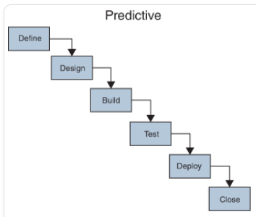
The Plan
I believe the best approach would be a predictive approach. This is due to needing to plan out every step to ensure a swift and low risk transition for both the laptop upgrades and networking upgrades. The following flow chart can be used to describe generally how the project will flow (See diagram to the left). The following steps would more accurately describe the plan:
Research Hardware Analyze Risks Order Hardware Inform Employees of Upgrades Test Deploy Changes Project Finished
To ensure a smooth transition, identification of any risks, and informing employees will be necessary action items. Some of the risks would include: impacting people’s ability to complete their daily tasks if the network is down for a prolonged time while they swap to the new router and switches, installing necessary software on peoples laptops and copying data from one laptop to another, and creating issues in the workplace due to people opposing a seemingly unnecessary upgrade. To assist in the execution of each location’s upgrades, the local IT department would be installing and configuring each router and switch to get them ready for the transition. Local IT would also be required to handle any issues relating to laptop upgrades and any local network issues. The project would be complete when all 150 employees have an updated laptop with each facility having updated networking hardware.
References
- Pearson. (n.d.). 3.1 Development Approach and Project Life Cycle Fundamentals. In Project Management Professional (PMP) Based on PMBOK7 (pp. 27–27). essay. Retrieved 2024, from https://www.ucertify.com/app/?func=ebook&chapter_no=4#top.

- Null, C. (2008). Get the Most of out of Your Laptop. PC World.

- Rotaru, D. A. (2021). CHOOSING THE MOST SUITABLE PROJECT MANAGEMENT METHODOLOGY (dissertation).

